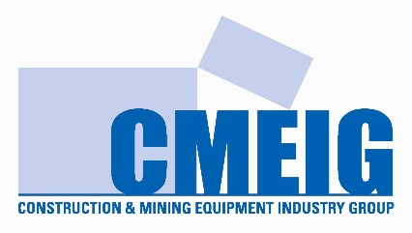

Skills Development Survey

Background:
CMEIG have historically had an active role in the development of skills training and the development of curricular for the heavy vehicle sector.
There is concern that core skills and future technology skills are not being identified and included in apprentice training courses. There is presently a skills shortage that will only be exacerbated directly affecting the ability of equipment suppliers and businesses to operate.
The intent of this survey is identify present skills gaps as part of developing a focussed approach to addressing the most urgent priorities. Your participation is appreciated.
It is envisaged that a Zoom meeting to collate responses and plan actions will follow.

Your Name: Role:

--------------------------------------------- ------------------------------------------------
Contact Details:

---------------------------------------------------------------------------------------------------------------------------
Business Name: Number of Apprentices Employed:

------------------------------------------ -----------------------------------------------

A: Underpinning Knowledge
Question 1: What core skills do you consider necessary to be included in apprentice training.

Question 2: List key gaps that you believe exist in the current training package.

B: Future Technology Skills
Question 3: What basic skills and knowledge do you consider necessary to deal with emerging technologies in the industry?

Question 4: What do you see as the key priorities?

C: Other
Question 5: What other training areas do you believe CMEIG should be engaged in to support the provision of qualified skilled people to the industry?

Please return to: David Birrell via email
birrell@cmeig.com.au

